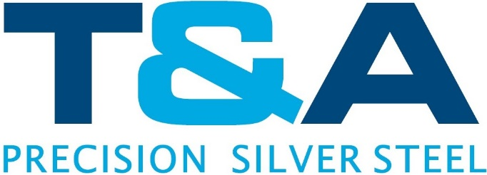

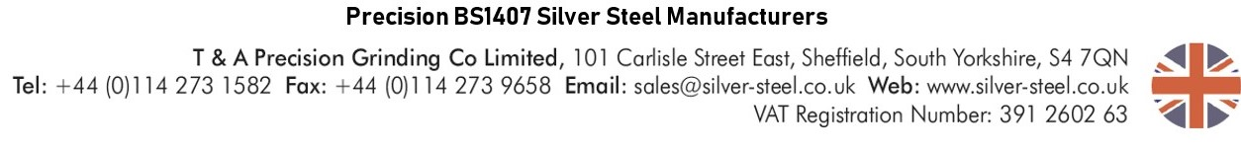
Certificate of Conformance

To whom it may concern,
T&A Precision hereby certifies that the material covered by this certificate has been tested in accordance with and has been found to meet the applicable requirements for the material including any specifications forming part of the description.

Identification of material: 260 Brass Shim ½ hard
SAE-CDA 260, ASTM-B-36
AMS-4507, MIL-C-10375
Rockwell: 30T 56/68
70% Copper
30% Zinc

Date:

Material Description:

Signed:

Andrew Oates
Managing Director

