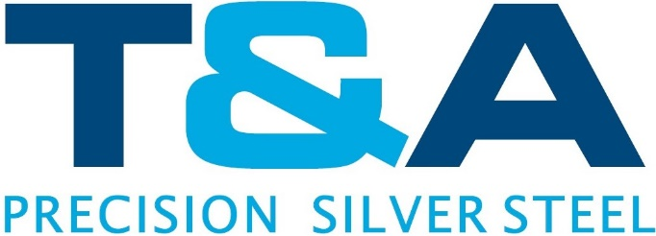

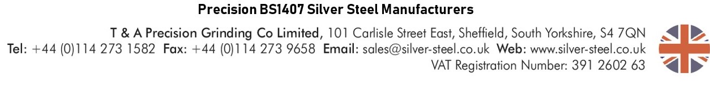
Certificate of Conformance

To whom it may concern,
T&A Precision hereby certifies that the material covered by this certificate has been tested in accordance with and has been found to meet the applicable requirements for the material including any specifications forming part of the description.

Identification of material: Stainless Steel Shim Type 300 Series Full Hard
ASTM A666
MIL-S-5059
QQS766
2B finish

Date:

Material Description:

Signed:

Andrew Oates
Managing Director

